**Experiment 30**

**Lab Book:**

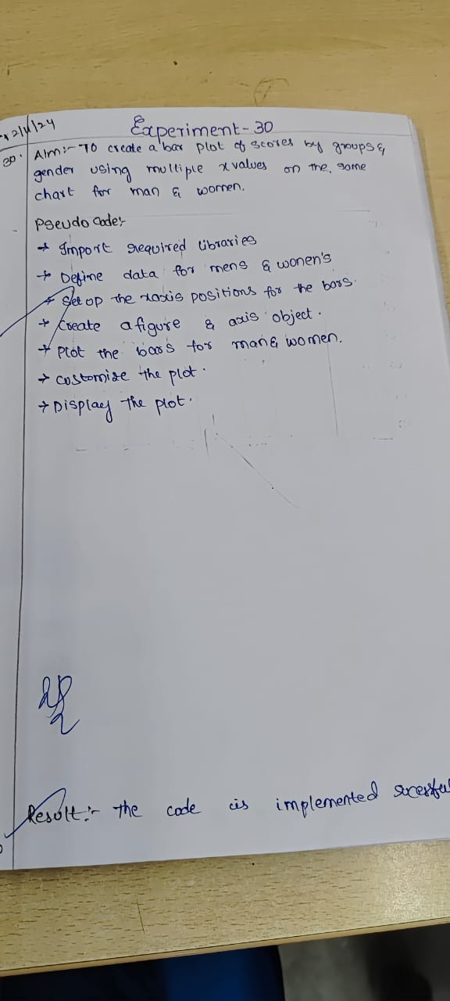

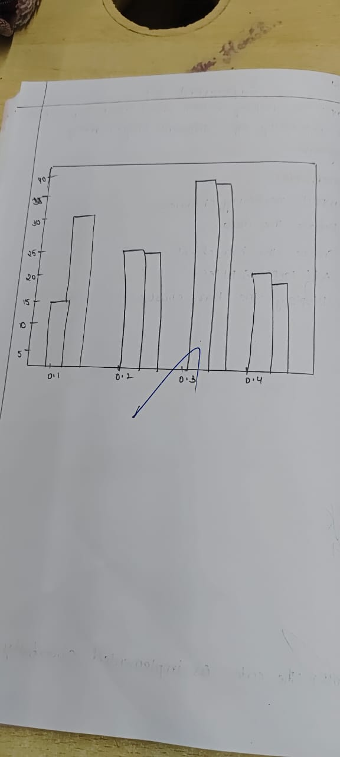

**Code**

import matplotlib.pyplot as plt

import numpy as np

men = [22, 30, 35, 35, 26]

women = [25, 32, 30, 35, 29]

labels = ['A', 'B', 'C', 'D', 'E']

x = np.arange(len(labels))

width = 0.35

fig, ax = plt.subplots()

ax.bar(x - width/2, men, width, label='Men')

ax.bar(x + width/2, women, width, label='Women')

ax.set_xlabel('Category')

ax.set_ylabel('Scores')

ax.set_title('Scores by category and gender')

ax.set_xticks(x)

ax.set_xticklabels(labels)

ax.legend()

plt.show()

**Sample Output**

